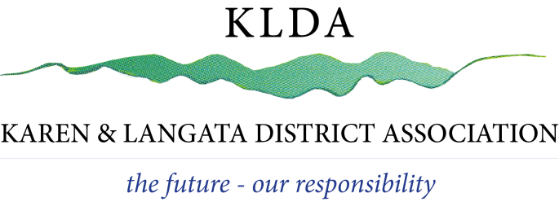
Date:

OUR REF: KLDA / EVENTS / _____ / 2023

The County Director of Environment
Nairobi County
P. O. Box 30075
Nairobi 00100

Email: Nairobi@nema.go.ke

Dear Sir or Madam

RE: APPROVAL LETTER FOR ___________

Karen and Langata District Association (KLDA) has received a request from ………………………to provide an approval letter to NEMA for an event being held on the ……………………………….. in their premises.

KLDA has agreed to issue this approval letter on the understanding that …………………………………….. will enforce the noise levels within …………………………decibel levels as per Regulation 8(1) of the 2009 EMAC Noise and Excessive Vibration Pollution Regulations and will comply with the permit conditions and noise control guidelines agreed with KLDA.

Yours faithfully,

SAMORA SIKALIEH M
CHAIRMAN-KLDA

c.c. Officer Commanding Station – Karen Police Station
Chief Officer, Department of Environment, Nairobi

