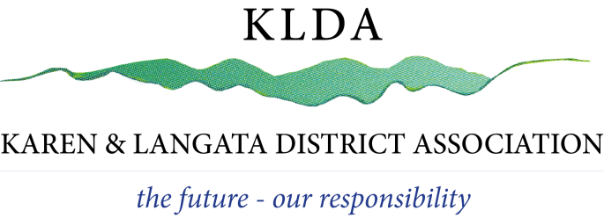Date:

OUR REF: KLDA / EVENTS / _____ / 2022

Applicant’s address details, etc

Dear

RE: APPLICATION LETTER FOR YOUR EVENT

Thank you for reaching out to us regarding your event and for choosing Karen as your event venue.
Kindly note that we have a new system and format for the approval of your application.
The following are the changes that have been made to this procedure:

1. ALL applications and future correspondence related to events and Noise Permit Applications will be made via address membership@klda.or.ke No applications should be dropped off.

2. No multiple approvals will be given to a venue/individual. All applications will be reviewed on an event-by-event basis.

3. The application for approval should be emailed to us at least two (2) weeks prior to the event.

4. It is strongly suggested that all venues have a decibel meter to accurately monitor the sound levels. To measure the sound level, you must measure it 30m from the source of the sound.

5. During the event you must have a copy readily available for review of the following: KLDA Approval Letter and the NEMA Noise Permit.

The requirements above have been updated, with the consideration that most of Karen is a residential area and there is a need to be accountable to the neighbours surrounding the venues concerned. Sadly, there has been a considerable increase in complaints from the community regarding noise pollution from venues across Karengata that are violating Regulation 8(1) of the Environmental Management and Coordination (Noise and Excessive Vibration Pollution (control) Regulations.

Please note that this may seem very time consuming, but once you have done the first application the next one will be a lot easier.

Thank you for your co-operation and we wish you an enjoyable event.

Yours faithfully

KLDA CHAIRPERSON

